**Homing errors treatment**

Beckhoff lists next errors groups:

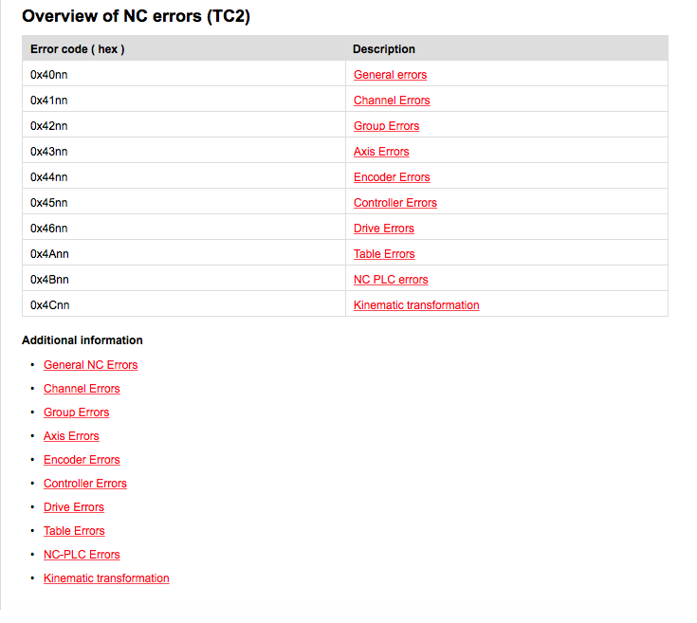

For homing errors I decided to have a new group: 0x4Dnn

For the moment next errors are implemented in MCAG_Base_Project.

1. At Mode 2 and Mode 3 after the limit switch it is not detected the Home Sensor. **Error Code: 0x4D02**
2. Home Sensor is detected but the motor doesn’t stop. **Error Code: 0x4D03**
3. At Mode 5 the Index input from the encoder is not detected. **Error Code: 0x4D04**
4. If nHomeRevOffset=0 an error is produced because it doesn’t make sense. **Error Code: 0x4D05**
5. Case there are more Index pulses introduced at nHomeRevOffset input than the motion system has comprised. **Error Code: 0x4D06**
6. If it is not searching for Sync Pulse at Mode 5. **Error Code: 0x4D07**
7. Case the load is in a limit switch and the motor continue working at least during 3 seconds. **Error Code: 0x4D08**